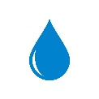
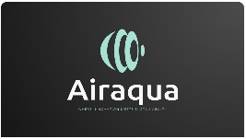
TECHNICAL INFORMATION SHEET

PERFLUORINATED COMPOUNDS REDUCTION
Perfluorinated compounds (PFAS) have become a significant concern in water treatment due to their persistence in the environment and potential health risks. AirAqua Carbons offers comprehensive solutions to address this challenge, including activated carbon, ion exchange resin, and expert services.
Our proprietary activated carbons, PF grades, are designed specifically for PFAS removal. Its unique pore structure, featuring a combination of micro, meso and macropores, provides exceptional performance in capturing and removing these contaminants from water sources.
Whether you're facing PFAS contamination in groundwater or surface water, AirAqua Carbons can provide tailored solutions to meet your specific needs.
SPECIFICATION

Iodine adsorption | minimum | 1000 mg/g
Apparent density | maximum | 440 kg/cum
Moisture content, as packed | minimum | 5%
Total ash content | maximum | 10%
Ball pan hardness | minimum | 93%

PF grade is suitable for treatment of water – ground & surface water.
PARTICLE SIZES AVAILABLE FEATURES AND BENEFITS
8x30
10x40 | Superior Hardness
12x40 | Clean and low ash content
Other sizes available on request | Drinking water grade
 | Approvals: NSF, Kosher & Halal
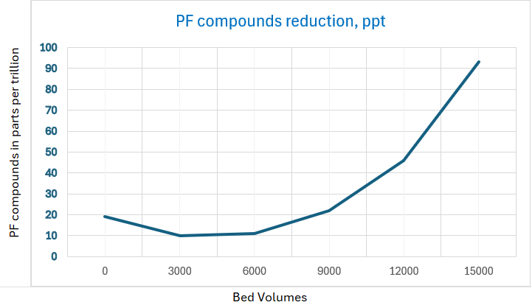
PF grades Exhibits high PFAS removal capabilities, leading to lower operational costs and improved treatment efficacy.
Activated carbon has a high surface area with numerous pores, allowing it to effectively adsorb PFOA/PFOS molecules from water. This high adsorption capacity ensures efficient removal, even at low concentrations.
Activated carbon technology is well-established and widely used for water treatment. Its reliability and proven effectiveness in removing various contaminants, including PFOA/PFOS, make it a trusted solution.
Compared to some emerging technologies, activated carbon is often a more cost-effective solution, especially for large-scale treatment applications. Its lower operational costs and relatively simple maintenance requirements contribute to its economic viability.

The graph shows the performance of PF 70 in a column test, with inlet PFOA/PFOS concentration of 700 ppt.
Gaia Carbon is based in Singapore and with plants in Johor Bahru, Malaysia. Gaia Cabron produces premium-quality coconut shell-based activated carbon to suit a diverse range of client needs – including water treatment, gas phase, precious metal extraction and polyvinyl acetate catalyst support application. Gaia Carbon takes pride in being able to produce a superior product designed to suit the client’s requirement. From the selection of raw material to the delivery of the final product, Gaia Carbon’s manufacturing procedures and process are governed by stringent quality control to ensure its product’s superiority. The processes and controls are supported by a management team with two decades of experience and expertise in activated carbon manufacturing and application.


